

*A Mini Project Report on*

**Muscle Fatigue Evaluation using Accelerometer and EMG**

*Submitted to the*

**DEPARTMENT OF   
ELECTRONICS AND INSTRUMENTATION ENGINEERING**

*In partial fulfillment of the requirements of the course*

**Bachelor of Engineering in Electronics and Instrumentation Engineering**

*By*

**Aman Verma 1MS19EI003**

**Chirag Sinha         1MS19EI014**

**Gopal Tyagi         1MS19EI015**

**Guru Manglam Siddhhe 1MS19EI017**

*Under the guidance of*

**Dr. G. Shivaprakash**

**Assistant Professor**

**RAMAIAH INSTITUTE OF TECHNOLOGY**

**(Autonomous Institute, Affiliated to VTU)**

**Bengaluru – 560054**

**2021-2022**



**CERTIFICATE**

This is to certify that the project work entitled “**Muscle fatigue evaluation using accelerometer and EMG**” is carried out by **Chirag Sinha 1MS19EI014, Aman Verma 1MS19EI003, Guru Manglam Sidhhe 1MS19EI017, Gopal Tyagi 1MS19EI017** are bonafide students of Ramaiah Institute Of Technology, Bengaluru in partial fulfilment for the award of Bachelor of Engineering in Electronics and Instrumentation Engineering of Visvesvaraya Technological University, Belagavi during the year 2021-22. It is certified that all corrections/suggestions indicated for Internal Assessment have been incorporated in the report deposited in the department library. The project report has been approved as it satisfies the academic requirements in respect of Project work prescribed for the said degree.

| **Project Guide**  **Dr G. Shivaprakash** |  | **Head of the Department**  **Dr M. K. PUSHPA** |
| --- | --- | --- |

**External Examiners**

**Name of Examiners: Signature with Date**

1.

2.



**ACKNOWLEDGEMENT**

We take this excellent opportunity to sincerely thank our HoD, Dr M K PUSHPA, Electronics and Instrumentation Engineering, RIT, and project co-ordinator Dr K.M Vanitha, Assistant Professor, Electronics and Instrumentation Engineering, RIT for letting us proceed with the idea of Muscle fatigue evaluation using accelerometer and EMG.

We are very thankful to our project guide Dr G. Shivaprakash for the constant support and guidance he has given throughout this process.

We express our heartfelt gratitude to the project panel for their constant support and encouragement. We would also like to thank all the faculty members of the department. They played a vital role during the course of the project by imparting their knowledge based on the respective subject that needed guidance and therefore helping us in this project.

**Team Members (Batch-11):**

**Aman Verma 1MS19EI003**

**Chirag Sinha         1MS19EI014**

**Guru Manglam Siddhhe                     1MS19EI017**

**Gopal Tyagi         1MS19EI015**

**ABSTRACT**

After the outbreak of COVID-19 in 2021 physical contact among people got minimal and everyone avoided the work which required human contact be it Schools, Offices or Gym. People started working from home and also, they tried to keep themselves fit during this tough time by the means of Home Gyms.

The report incorporates fatigue measurement using EMG and accelerometer which will help a user improve their capability to lift heavy weights and save them from muscle injuries without any human contact. The implementation of the hardware has been discussed along with supporting images and block diagrams.

We here focus on counting the repetition of each exercise with the help of an accelerometer and measuring the fatigue using EMG. Furthermore, the scope of work accompanied by its application has been appended in the report.

**TABLE OF CONTENTS**

| Acknowledgment 3 |  |
| --- | --- |
| Abstract 4 |  |
| List of Figures 6 |  |
| | 1. |  | **Introduction 8** | | --- | --- | --- | |  | 1.1 | Literature survey 9 | |  | 1.2 | Scope of the work 10 | |  | 1.3 | Objectives 10 | |  | 1.4 | Organization of the report 11 | | 2. |  | **Methodology 12** | |  | 2.1 | Theory 13 | |  | 2.2 | Algorithm 14 | |  | 2.3  2.4 | Block Diagram 15  Hardware Block Diagram 16 | |  | 2.5 | Hardware and software selection 20 | | 3. |  | **Implementation 22** | |  | 3.1 | Introduction 23 | |  | 3.2  3.3 | Software Part 23  Simulation 24 | |  | 3.4 | Hardware Interface 18 | | 4. |  | **Data Set 28** | | 5. |  | **Result 29** | | 6. |  | **Conclusion 33** | |  |  |  | | 8. |  | **References 35** | |  |
| |  |  |  | | --- | --- | --- | |  |  |  | |  | **CHAPTER 1:**  **INTRODUCTION** |  | |  |  |  | |  |  |  | |  |  |  | |  |  |  | |  |  |  | |  |  |  | |  |  |  | |  |  |  | |  |  |  | |  |  |  | |  |  |  | |  |  |  | |  |  |  | |  |  |  | |  |  |  | |  |  |  | |  |  |  | |  |  |  | |  |  |  | |  |  |  | |  |  |  | |  |
|  |  |

**INTRODUCTION**

We know that the pandemic took an outsize toll on public health and had a far-reaching impact on all business sectors, including the fitness industry. A surge in home-based workouts wasn’t surprising during widespread stay-at-home orders and mandated gym closures in all of the states at the beginning of April. However, now that vaccinations and other safety measures are in place in many areas, fitness clubs have reopened. A majority (80.4%) of consumers polled by Upswell Marketing are open to going back to the gym, and 40% said they’d actually prefer to work out at a gym rather than home — as long as the space felt safe and clean. Nearly half (46.8%) of those surveyed said sanitation is one of the deciding factors for choosing a gym.

Some of the major drawbacks of a home gym are too much flexibility, no accountability and no contact with the Gym Trainer due to which people often overdo themselves and get injured, So to prevent this we are proposing a way which will not require anyone to go to Gym or any contact with Gym trainers or any third person. In this report, we are going to explain how we can use EMG and accelerometer to overcome this issue.

An accelerometer is an instrument used for measuring the acceleration of a moving or vibrating body, it has measure acceleration along 3 axis -X, -Y & -Z respectively so by using the properties of the Accelerometer we can measure the number of repetitions for a particular exercise and it will help us to keep track of each day and by utilising the properties of EMG we can measure the fatigue in the muscle which is under consideration currently by coving these two data a user can know how much exercise is sufficient for the day and can avoid muscle injuries.



Fig 1: Dumbbell pull-up Exercise

**1.1 LITERATURE SURVEY**

With the help of “M. Ayaz, M. W. Ayub and I. A. Qureshi, "Arduino Based Fatigue Level Measurement in Muscular Activity using RMS Technique” paper concluded that how we can categorize fatigue levels using RMS voltage and BMI.[1]

The "Oliveira AS, Gonçalves M, Cardozo AC, Barbosa FS. Electromyographic fatigue threshold of the biceps brachii muscle during dynamic contraction. Electromyography and Clinical Neurophysiology" talks about the results of their research showed a progressive increase in RMS with time, for both brachial muscles in all loads, characterizing the muscle fatigue process.[2]

According to the study of “Oliveira, A. de, &amp; Gonçalves, M. (2009). EMG amplitude and frequency parameters of muscular activity: Effect of resistance training based on electromyographic fatigue threshold” a Journal on Electromyography and Kinesiology we got to know about the improvement in fatigue level of brachial muscle after regular training.[3]

“Bello Salau, Habeeb & Onumanyi, Adeiza & Aibinu, A. & Onwuka, Liz & Dukiya, Jaiye & Ohize, Henry. (2019). A Survey of accelerometer-based Techniques for Road Anomalies Detection and Characterization” this paper deals with the road anomaly detection by the use of the accelerometer in different axes. Each axis gives the corresponding acceleration which later can be converted into distances.[4]

A journal on Computer and Communication by “W.M., Fang, L.Q., Xu, L., Li, X., Huo, R.K., Guo, D.Q. and Qi, Z.Y. (2018) Summary of Research Status and Application of MEMS Accelerometers” tells about why MEMS accelerometer advantages.MEMS Accelerometer is very useful as it is Highly integrated into the system, very light-weighted, and easy to use.[5]

The paper “Full-featured pedometer design realized with 3-axis digital accelerometer. Analog Dialogue” by Zaho, N., 2010 gave us an idea about how we can use the maximum and minimum acceleration values of each axis to count the number of steps for a moving body under a threshold value.[6]

The book “Rep Counter for Weightlifting” by Ryan May helped us to know how we can use uses a Capacitive accelerometer which has a semiconductor material used as pair of beams, when the distance between beams changes the voltage across the capacitor changes.[7]

**1.2 SCOPE OF THE WORK**

Pre pandemic when things were normal it was easy for people to go to Gym, take the help of gym trainers and continue their exercises but after the pandemic people have avoided human contact as much as possible due to which they have started using a home gym. Now one of the major concerns with home Gym is that one doesn't know how much exercise is enough for the day due to which they injure themselves. We are planning to fill this gap with the help of our project which is Going to count the number of repetitions of the current exercise and also measure the fatigue in the muscle which is currently under consideration and it may help the user to analyse their performance daily and they can keep a record of their exercise and avoid serious injuries. The design is simple enough for any person to implement.

**1.3 OBJECTIVES**

* To keep a count of each repetition of the exercise currently under consideration
* To notify the user on the basis of a number of current repetitions of the exercise about the level of fatigue they have in the muscle which is divided into two levels: Low fatigue, and High fatigue.

**1.4 ORGANISATION OF THE REPORT**

This report gives a basic description of how we are going to implement our project and the literature survey included here gives us an idea of how to implement various innovations and overcome the problems that are faced in the development process.

In order to provide an easier understanding of the following project, it has been organized into particular categories. Following are the categories:

* Chapter 1: It includes the basic idea behind selecting the project, literature survey, objectives and scope of work.
* Chapter 2: It consists of a basic introduction to the project and the basic block diagram of the overall system.
* Chapter 3: It explains the hardware and software sections with implementation details.
* Chapter 4: It explains the results obtained from the existing model of the project.
* Chapter 5: This chapter has the conclusion of the project.

**CHAPTER 2:**

**METHODOLOGY**

**METHODOLOGY**

**2.1 THEORY:**

The basic underlying working principle of an accelerometer is such as a dumped mass on a spring. When acceleration is experienced by this device, the mass gets displaced till the spring can easily move the mass, with the same rate equal to the acceleration it sensed. Then this displacement value is used to measure the acceleration. This technique has been utilized to calculate activity counts by tuning the threshold line position at two-thirds of the range between the minimum and maximum. When the accelerometer data cross the line in a positive direction, one count would be added. After adding each count, a refractory period of 0.5 seconds has occurred to prevent counting another repetition needlessly.

“A typical pattern of x-, y-, and z- measurements corresponding to vertical, forward, and side acceleration of a running person. At least one axis will have relatively large periodic acceleration changes, no matter how the accelerometer is worn, so peak detection and a dynamic threshold-decision algorithm for acceleration on all three axes are essential for detecting a unit cycle of walking or running. The system continuously updates the maximum and minimum values of the 3-axis acceleration every 50 samples. The average value, (Max + Min)/2, is called the dynamic threshold level; this threshold level is used to decide whether steps have been taken. As it is updated every 50 samples, the threshold is dynamic. This choice is adaptive and fast enough.”[Zhao Paper] By using a similar idea we can approach counting the repetition of an exercise.

Measuring muscle activation via electric potential, referred to as electromyography (EMG), has traditionally been used for medical research and diagnosis of neuromuscular disorders. However, with the advent of ever shrinking yet more powerful microcontrollers and integrated circuits, EMG circuits and sensors have found their way into prosthetics, robotics and other control systems. Muscle Sensors are designed to be used directly with a microcontroller. Therefore, our sensors do not output a RAW EMG signal but rather an amplified, rectified, and smoothed signal that will work well with a microcontroller’s analog-to-digital converter (ADC).

Fig 2.1: Snapshot of a small-loop device fed by a regular sequence of droplets

**2.2 ACCELEROMETER**: The accelerometer used in this project is a 3-axis analog accelerometer. The sensor is a low-profile capacitive accelerometer. The mechanical structure, which is made of semiconductor materials, can be modelled as a set of beams attached to a movable central mass that moves between fixed beams. These movable beams move from their stationary position when it experiences acceleration. Essentially, there are 2 variable capacitances, one on each side of the moving beam. The changes in distance between the beams (increasing area for a capacitor) cause changes in the voltage output, which is then used to calculate the acceleration.[BOOK]

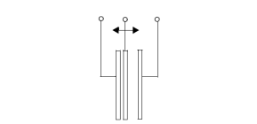

Fig 2.1. Simplified model of accelerometer

The equations for each axes is discussed here,

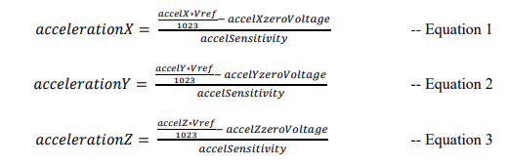

**2.3 EMG:** Electromyography (EMG) is a diagnostic procedure to assess the health of muscles and the nerve cells that control them (motor neurons). EMG results can reveal nerve dysfunction, muscle dysfunction or problems with nerve-to-muscle signal transmission.

**2.4 FUNCTIONAL BLOCK DIAGRAM:**

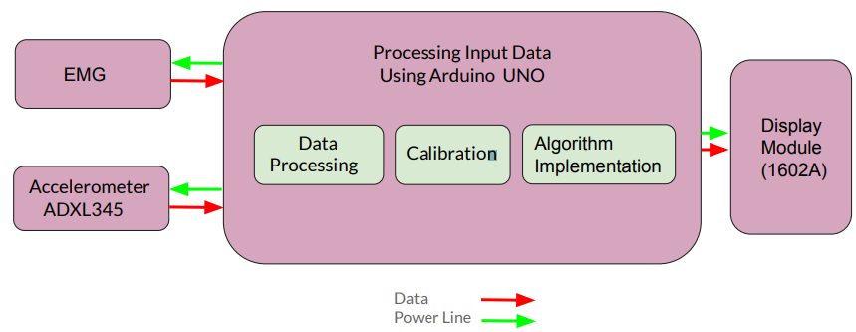Fig 2.2. Functional Block Diagram

* Emg and Accelerometer signals will be fed to Arduino. Inside the Arduino the processing of those signals will take place. Apart from this, the calibration of the sensors is also done and then finally the algorithm is implemented inside the Arduino itself. Finally, the processed data will be displayed on the display module.

**2.5 HARDWARE AND SOFTWARE SELECTION:**

**Hardware & Software selection**

* 1. ARDUINO UNO
  2. ADXL345 Accelerometer
  3. Myoware Muscle Sensor V 3.0
  4. Sticky pads electrodes
  5. Breadboard
  6. 16 x 1 LCD Display
  7. 9-V Batteries
  8. 20 Ohm Resistor
* **ADXL345 Accelerometer** Ultra-low-power 25 to 130 μA at VS=2.5 V (Typ)

Power consumption scales automatically with bandwidth User-selectable fixed 10-bit resolution or 4mg/LSB scale factor in all g-ranges, up to 13-bit resolution at ±16g 32 level output data FIFO minimizes host processor load. Built-in motion detection functions.

•Tap/Double Tap detection.

•Activity/Inactivity monitoring.

•Free-Fall detection. Supply and I/O voltage range: 1.8 V to 3.6 V. I2C digital interfaces. Wide temperature range (-40 to +85°C). 10,000g shock survival. Small and thin: 3 × 5 × 1 mm.

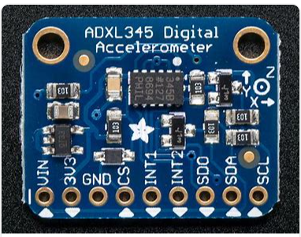

* **Myoware Muscle Sensor V 3.0**

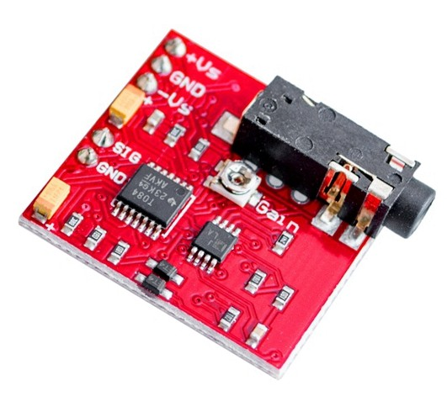

Pin Layout

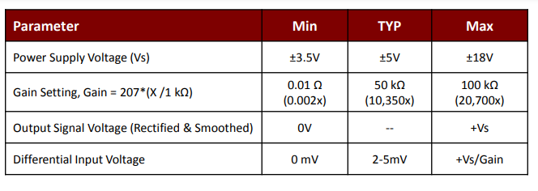

Electrical Specification

* **Power supply unit:**Two 9V battery is serving as a Power Supply Unit for EMG. For the accelerometer, we need a 5V supply which is given using Arduino and Arduino is given a power supply using a Laptop.

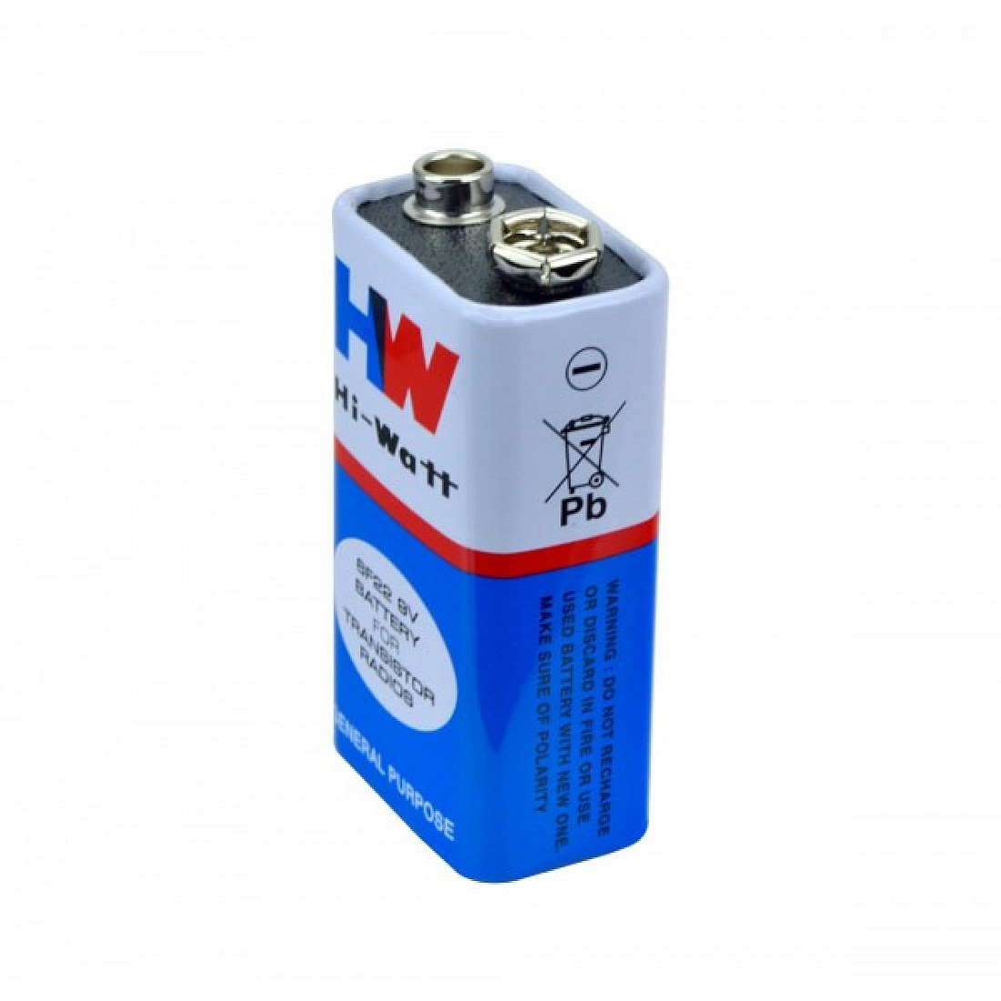

Fig 2.4: Power supply unit.

* **Arduino:**The Arduino board is the brain of the system. The Arduino board receives data from the Accelerometer and EMG, processes the data and sends it to the LCD display. The Arduino typically comes with a USB cord to communicate with a laptop.  As mentioned, it can also be powered directly from the computer.  Simply attach the cable to the Arduino and your computer.

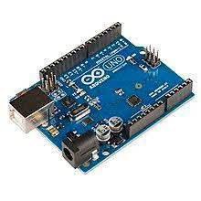

Fig 2.5: Arduino UNO.

**CHAPTER 3:**

**IMPLEMENTATION**

**3.1 INTRODUCTION**

A simple model to represent the number of counts of repetitions of the current exercise under consideration and to notify them about their fatigue level on the basis of the current repetition count.

**3.2 HARDWARE INTERFACING**

Our project setup can be broken down into three basic areas:

1) Accelerometer,

2) Myoware Muscle Sensor v 3.0, and

3) Ardunio interfacing

* **Accelerometer**

The ADXL345 accelerometer is used to measure acceleration along three axes which are X-, Y- and Z-. We required the following pin connection to make it work,

* It requires a 5-V voltage supply so, the Vin pin of the accelerometer is connected to the 5-V pin of Arduino.
* The GND pin of the accelerometer is connected to the GND pin of the Arduino.
* The SCL (Secondary Clock Line) pin of the accelerometer is connected to the A4 pin of the Arduino.
* The SDA (Secondary Data Line) pin of the accelerometer is connected to the A5 pin of the Arduino.

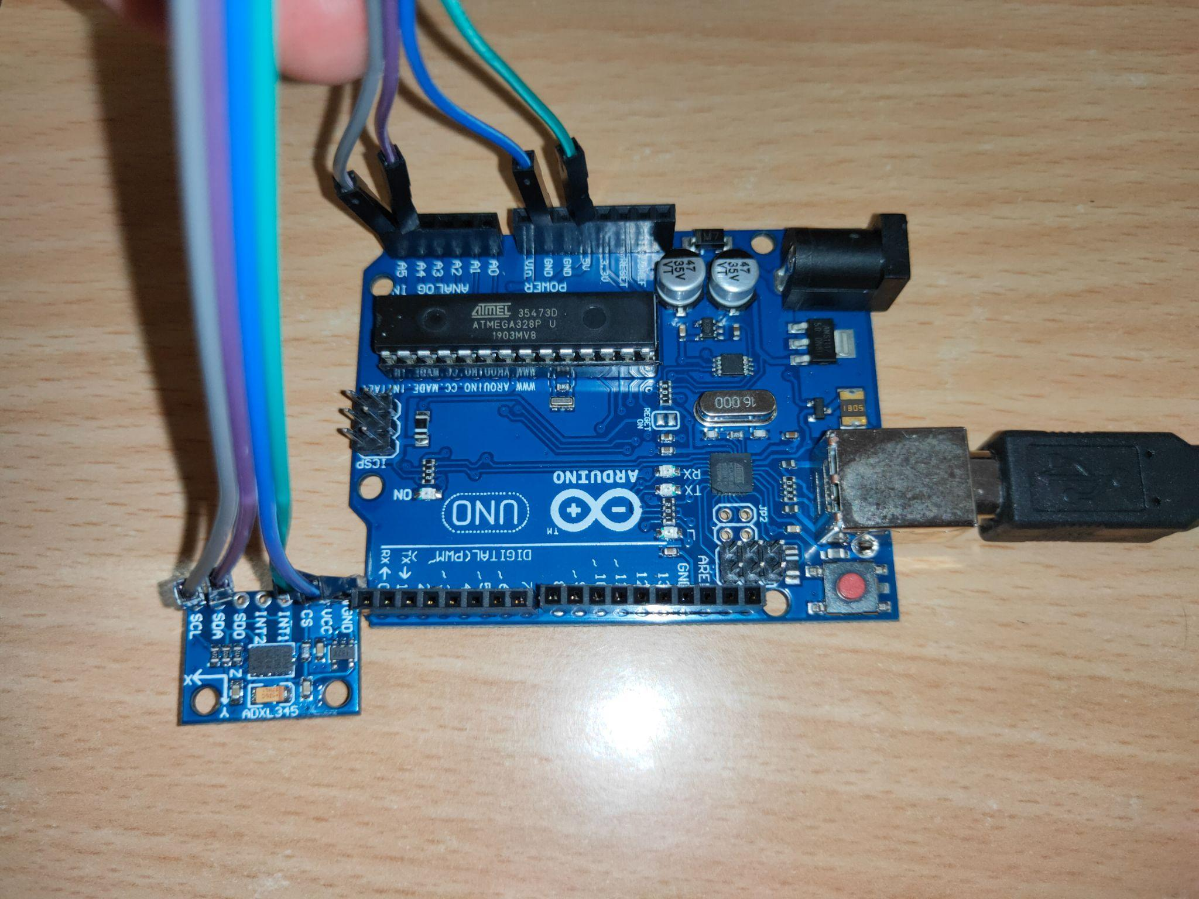

As the accelerometer is only giving us the “g” value along each axis so we are considering one particular orientation let's say along Z-axis, now initially “g” will be +10 m/s^2 i.e the hand is currently in the horizontal state which will be changed to 0 m/s^2 i.e the hand is in the middle position and then to -10 m/s^2 then we consider this as one complete repetition.

* **Myoware Muscle Sensor V 3.0**

Myoware is used to measure muscle activation via electric potential also referred to as electromyography (EMG), with the advent of ever shrinking yet more powerful microcontrollers and integrated circuits, EMG circuits and sensors have found their way into prosthetics, robotics and other control systems.

We required the following pin layout connection to use Myoware,

* It requires an 18-V supply so we have connected two 9-V batteries in series along +Vs (+9-V), GND and -Vs (-9-V) pins of Myoware.
* The SIG (signal) pin of the Myoware is connected to the A0 pin of the Arduino.
* The GND (ground) pin of the Myoware is connected to the GND pin of the Arduino.

First, we connect the Myoware to the muscle of the subject with the help of sticky pad electrodes. Initially, when the muscle is at rest, the analog input is given to the Myoware as the muscle activity increases the analog input across the Myoware increases.  
The Arduino receives analog input from the Myoware it processes that data which is then converted to the digital form and is shown to us, the value varies from 0 to 1023 where 0 means the lowest fatigue level and 1023 means high fatigue value in the active state, so we are dividing this received input from Arduino by 1000 and considering the value is varying from 0 to 1 and using these values we will notify the subject about the fatigue level, following is the scaling which is being considered,

* 0 to 0.5 is considered as low fatigue/No fatigue
* Above 0.5 is considered as high fatigue.

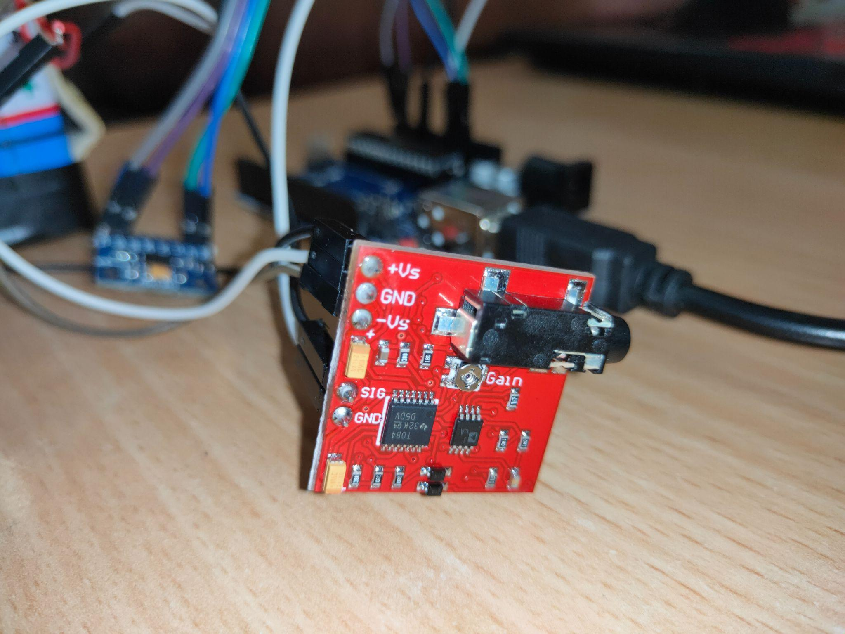

* **Hardware Connections**

 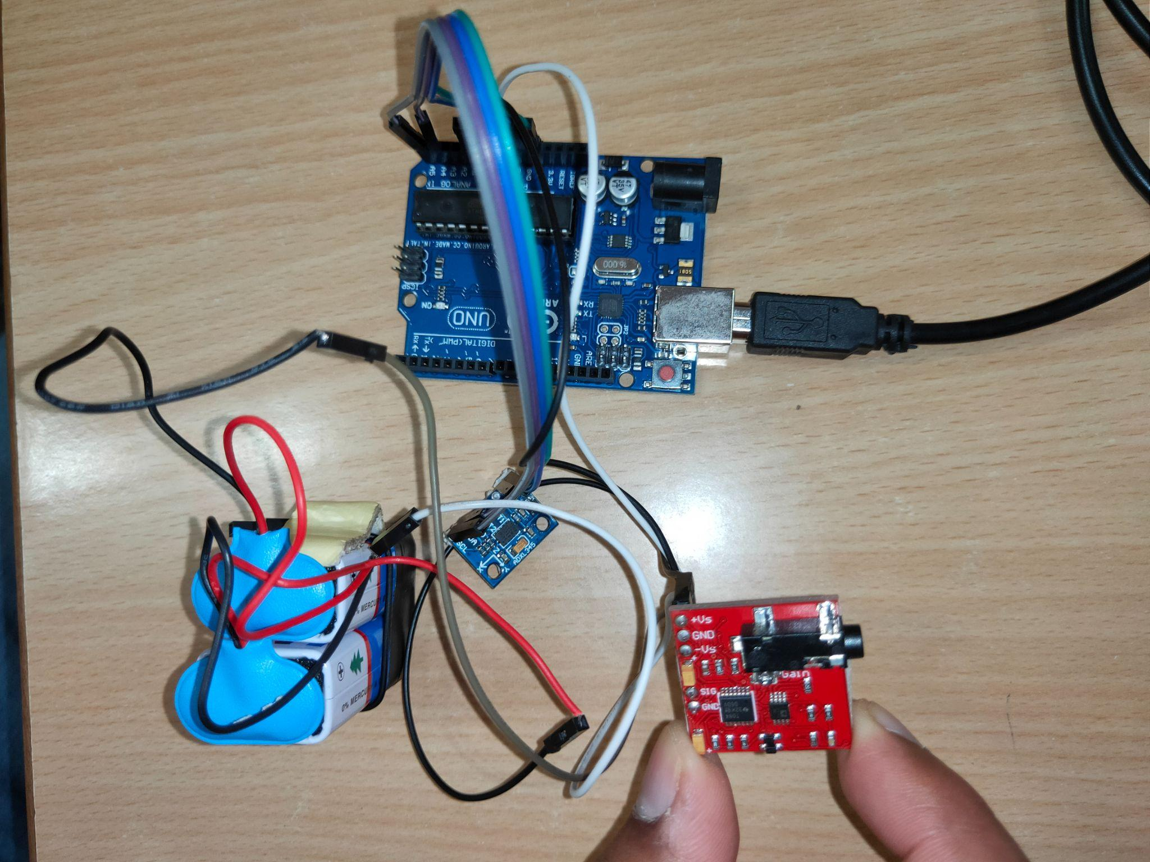

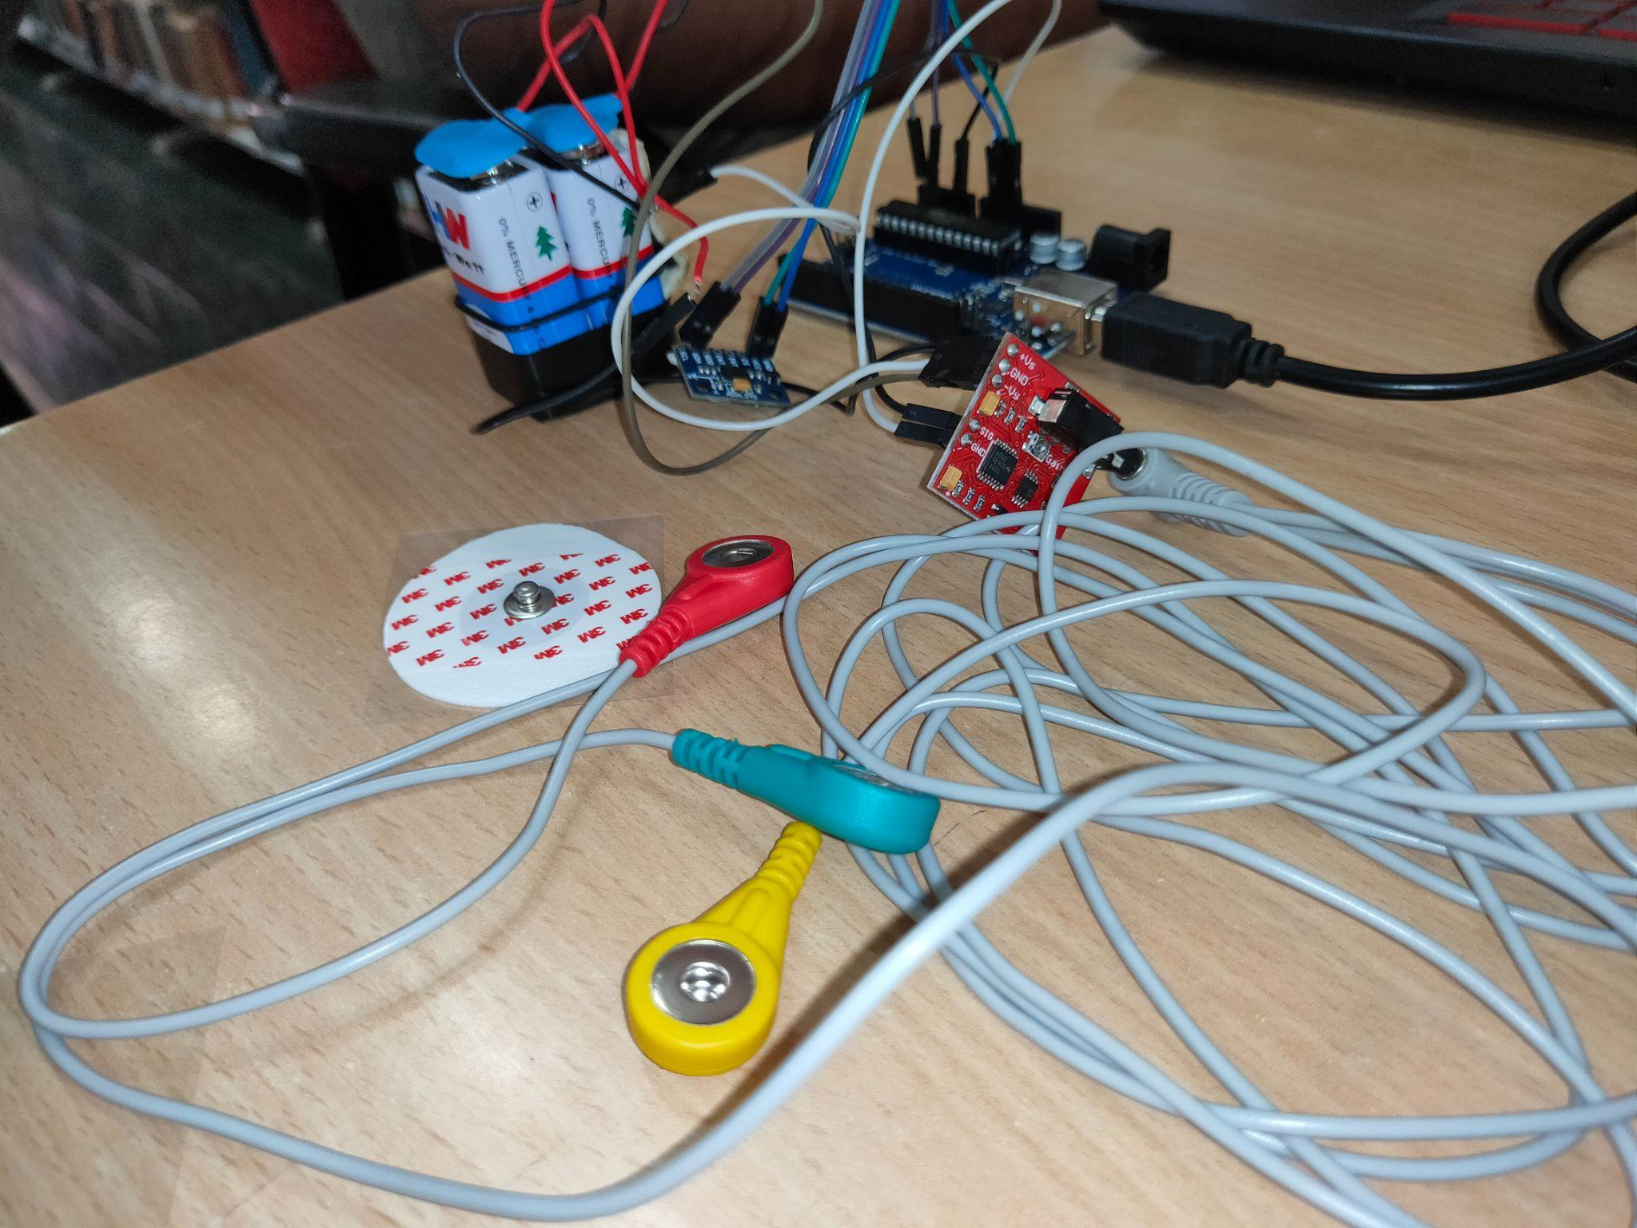 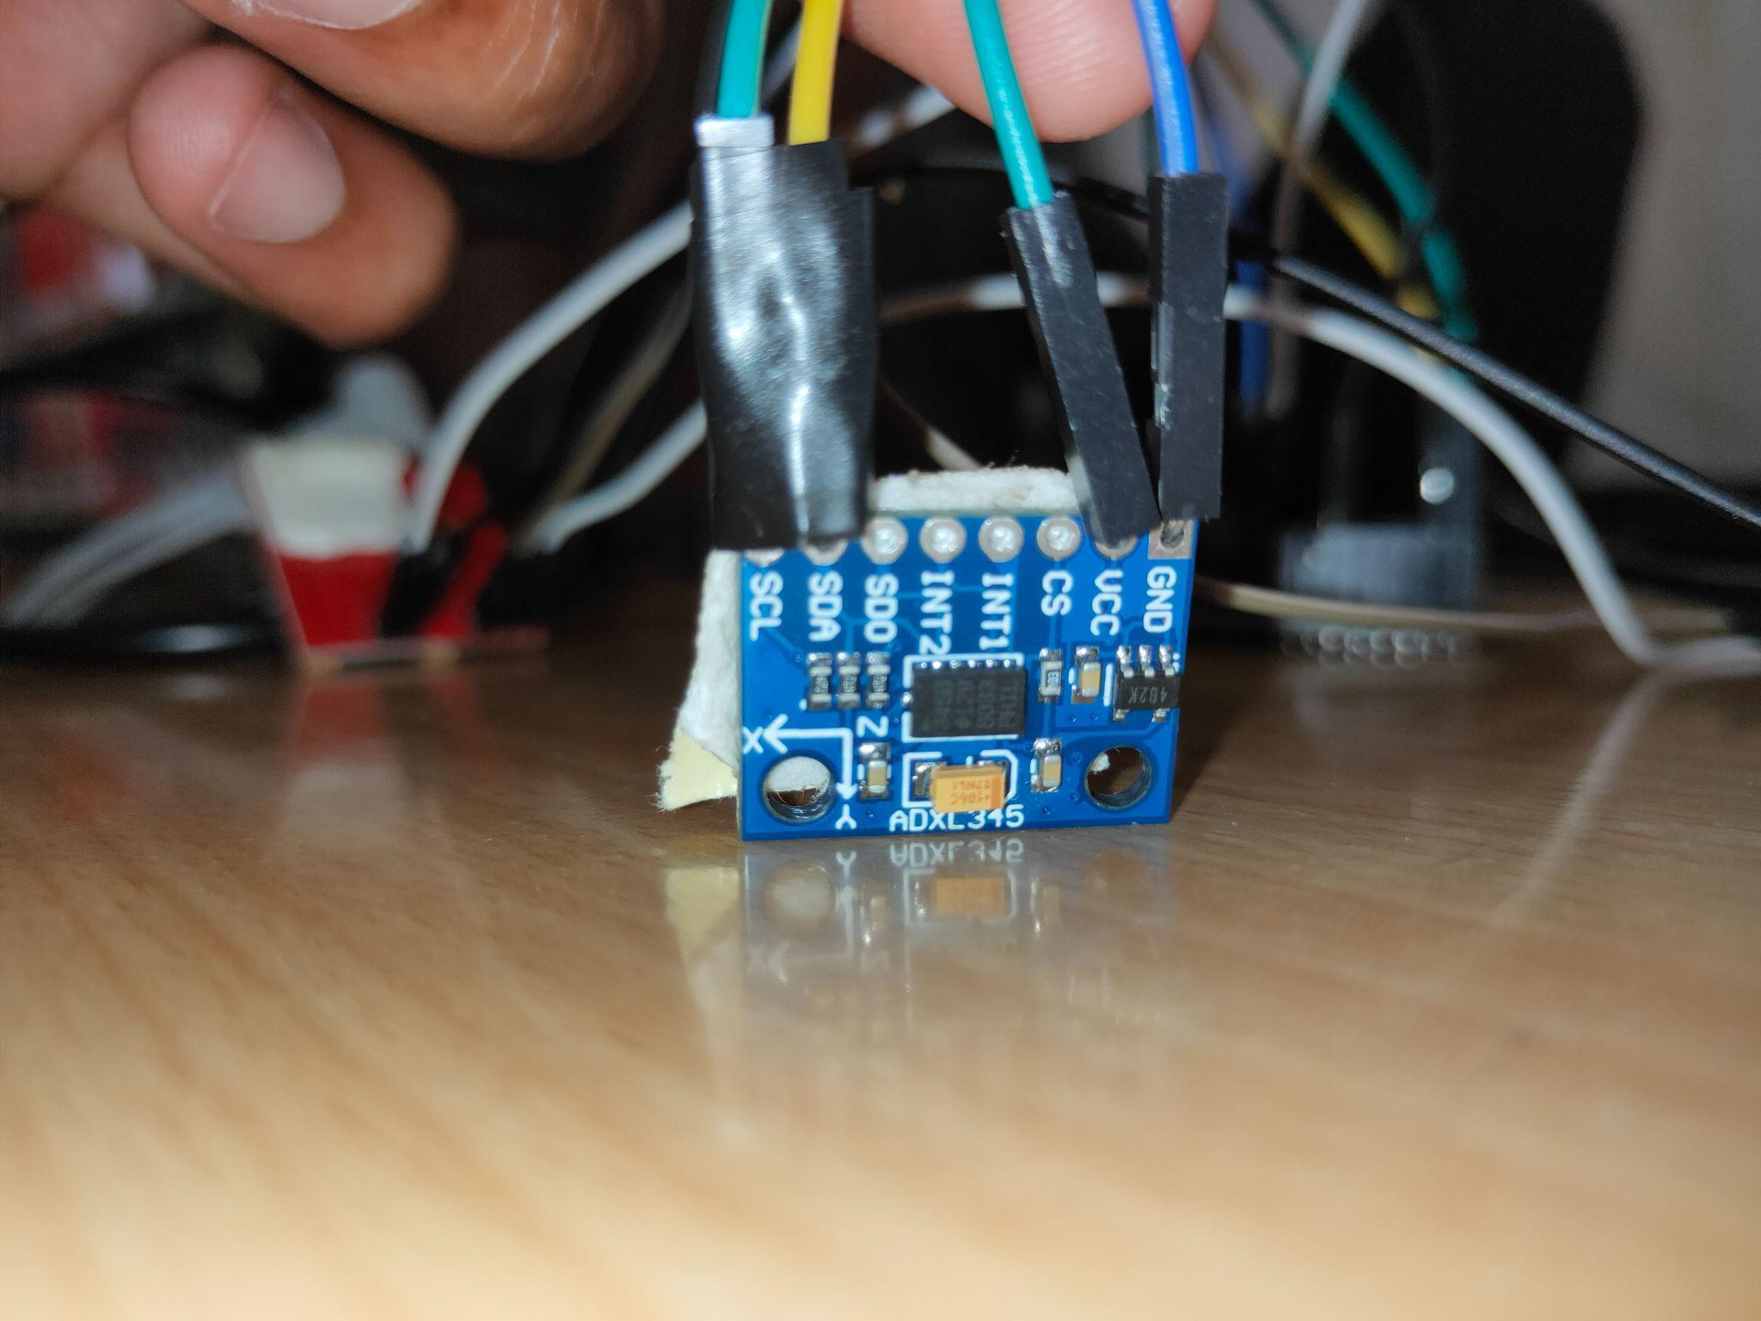

* **Arduino Code**

The code for the Arduino determines the number of repetitions of the particular exercise under consideration and on the basis of input given by the Arduino it is displaying whether the user is under fatigue or not.

0.3-0.59

0.3

#include <Wire.h>

#include <Adafruit_Sensor.h>

#include <Adafruit_ADXL345_U.h>

#include <LiquidCrystal.h>

Adafruit_ADXL345_Unified accel = Adafruit_ADXL345_Unified();

int xx=-50,yy=-50,zz=-50,count=0,ph=0;

const int rs = 2, en = 3, d4 = 4, d5 = 5, d6 = 6, d7 = 7;float rms;int pv,cr;

LiquidCrystal lcd(rs, en, d4, d5, d6, d7);

void setup() {

if(!accel.begin())

{

Serial.println("No valid sensor found");

while(1);

}

Serial.begin(9600);

lcd.begin(16, 2);

}

void loop() {

float val1=analogRead(A0);

val1/=1023;

// Serial.println(val1/1023);

val1=val1*val1;

acc();

lcddisplay();

// delay(500);

float val2=analogRead(A0);

val2/=1023;

val2=val2*val2;

acc();

lcddisplay();

// delay(500);

float val3=analogRead(A0);

val3/=1023;

val3=val3*val3;

acc();

lcddisplay();

// delay(500);

float val4=analogRead(A0);

val4/=1023;

val4=val4*val4;

acc();

lcddisplay();

// delay(500);

float val5=analogRead(A0);

val5/=1023;

val5=val5*val5;

acc();

lcddisplay();

// delay(500);

float val6=analogRead(A0);

val6/=1023;

val6=val6*val6;

acc();

lcddisplay();

// delay(500);

float val7=analogRead(A0);

val7/=1023;

val7=val7*val7;

acc();

lcddisplay();

// delay(500);

float val8=analogRead(A0);

val8/=1023;

val8=val8*val8;

acc();

lcddisplay();

// delay(500);

float val9=analogRead(A0);

val9/=1023;

val9=val9*val9;

acc();

lcddisplay();

// delay(500);

float val10=analogRead(A0);

val10/=1023;=val1+val2+val3+val4+val5+val6+val8+val7+val9+val10;

rms = sqrt(sum/10);

// Serial.println(sum/10);

Serial.println();

// delay(1000);

}

void acc()

{

sensors_event_t event;

accel.getEvent(&event);

xx=event.acceleration.x;

yy=event.acceleration.y;

zz=event.acceleration.z;

if(xx<0 && ph==0)

ph=1;

else if(zz>0 &&ph==1)

ph=2;

else if(xx>0 && ph==2)

ph=3;

else if (zz>0 && ph==3)

ph=4;

else if(xx<0 && ph==4)

{

count+=1;

ph=1;

}

Serial.println(count);

delay(100);

accel.getEvent(&event);

xx=event.acceleration.x;

yy=event.acceleration.y;

zz=event.acceleration.z;

if(xx<0 && ph==0)

ph=1;

else if(zz>0 &&ph==1)

ph=2;

else if(xx>0 && ph==2)

ph=3;

else if (zz>0 && ph==3)

ph=4;

else if(xx<0 && ph==4)

{

count+=1;

ph=1;

}

Serial.println(count);

delay(100);

accel.getEvent(&event);

xx=event.acceleration.x;

yy=event.acceleration.y;

zz=event.acceleration.z;

if(xx<0 && ph==0)

ph=1;

else if(zz>0 &&ph==1)

ph=2;

else if(xx>0 && ph==2)

ph=3;

else if (zz>0 && ph==3)

ph=4;

else if(xx<0 && ph==4)

{

count+=1;

ph=1;

}

Serial.println(count);

delay(100);

accel.getEvent(&event);

Serial.print("X: "); Serial.print(event.acceleration.x); Serial.print(" ");

Serial.print("Y: "); Serial.print(event.acceleration.y); Serial.print(" ");

Serial.print("Z: "); Serial.print(event.acceleration.z); Serial.print(" ");

Serial.println("m/s^2 ");

xx=event.acceleration.x;

yy=event.acceleration.y;

zz=event.acceleration.z;

if(xx<0 && ph==0)

ph=1;

else if(zz>0 &&ph==1)

ph=2;

else if(xx>0 && ph==2)

ph=3;

else if (zz>0 && ph==3)

ph=4;

else if(xx<0 && ph==4)

{

count+=1;

ph=1;

}

Serial.println(count);

delay(100);

accel.getEvent(&event);

xx=event.acceleration.x;

yy=event.acceleration.y;

zz=event.acceleration.z;

if(xx<0 && ph==0)

ph=1;

else if(zz>0 &&ph==1)

ph=2;

else if(xx>0 && ph==2)

ph=3;

else if (zz>0 && ph==3)

ph=4;

else if(xx<0 && ph==4)

{

count+=1;

ph=1;

}

Serial.println(count);

delay(100);

accel.getEvent(&event);

xx=event.acceleration.x;

yy=event.acceleration.y;

zz=event.acceleration.z;

if(xx<0 && ph==0)

ph=1;

else if(zz>0 &&ph==1)

ph=2;

else if(xx>0 && ph==2)

ph=3;

else if (zz>0 && ph==3)

ph=4;

else if(xx<0 && ph==4)

{

count+=1;

ph=1;

}

Serial.println(count);

delay(100);

}

void lcddisplay(){

if(pv!=count)

{pv=count;

if(rms>.45)

{lcd.clear();

lcd.print("High Fatigue");

lcd.setCursor(0, 1);

lcd.print(count);

}

else

{lcd.clear();

lcd.print("Low Fatigue");

lcd.setCursor(0, 1);

lcd.print(count);

}

}

}

**Data Sets**

| **Name** | **No. of Repetition** | **Low fatigue/no fatigue** | **Fatigue detected** |
| --- | --- | --- | --- |
| Harshitha | 36 | 0.3-0.40 | 0.40>= |
| Ambika | 45 | 0.3-0.47 | 0.47>= |
| Hansa | 40 | 0.3-0.44 | 0.47>= |
| Gunjan | 43 | 0.3-0.50 | 0.50>= |
| Pooja | 44 | 0.3-0.52 | 0.52>= |
| Sonal | 35 | 0.3-0.40 | 0.40>= |
| Ishita | 46 | 0.3-0.53 | 0.53>= |
| Vaishnavi | 37 | 0.3-0.42 | 0.42>= |

| **Name** | **No. of Repetition** | **Low fatigue/no fatigue** | **Fatigue detected** |
| --- | --- | --- | --- |
| Abhishek | 45 | 0.3-0.47 | 0.47>= |
| Abhay | 55 | 0.3-0.57 | 0.57>= |
| Preet | 54 | 0.3-0.51 | 0.51>= |
| Parth | 60 | 0.3-0.59 | 0.59>= |
| Ritik | 48 | 0.3-0.51 | 0.51>= |
| Jai | 56 | 0.3-0.54 | 0.54>= |
| Danish | 59 | 0.3-0.59 | 0.59>= |
| Prakhar | 57 | 0.3-0.60 | 0.60>= |

**CHAPTER 4:**

**RESULTS**

**RESULTS**

We measured the fatigue and repetition count on different subjects both male and female and the result data set is attached below,

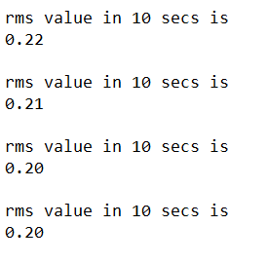

Fig 4.1

*In this figure the rms value of fatigue is given.*

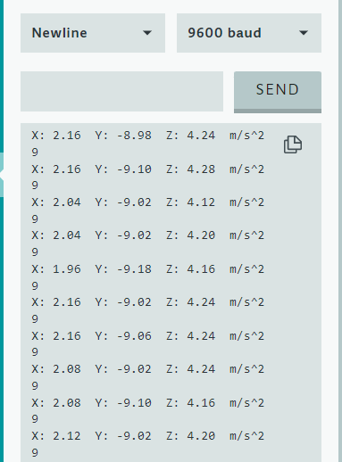

Fig 4.2

*Acceleration Values in X,Y and Z axis.*

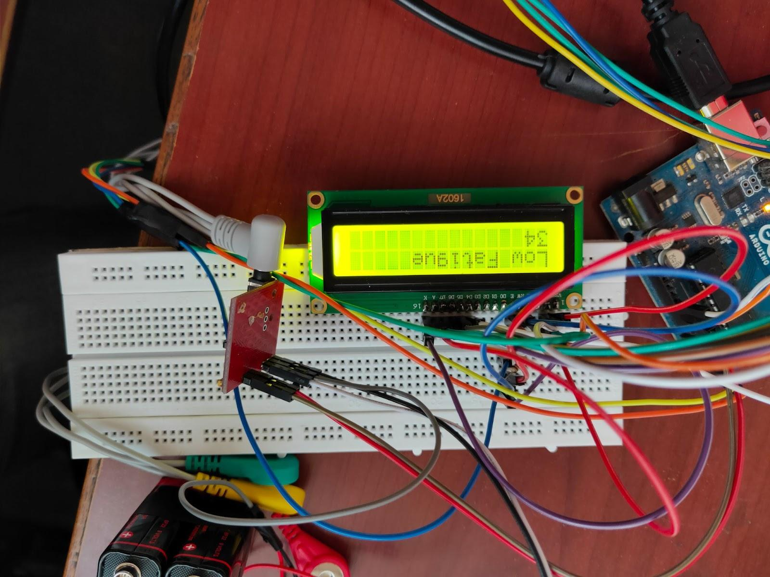

Fig 4.3:

Result Display

**CHAPTER 5:**

**CONCLUSION**

**CONCLUSION**

* Successfully able to count the number of repetitions of the particular exercise under consideration
* Successfully predicted whether the subject is under fatigue or not

**REFERENCES**

1. Ma, B., Li, C., Wu, Z. et al. Muscle fatigue detection and treatment system driven by the internet of things. BMC Med Inform Decis Mak 19, 275 (2019). https://doi.org/10.1186/s12911-019-0982-x
2. Bourke AK, O'Brien JV, Lyons GM. Evaluation of a threshold-based tri-axial accelerometer fall detection algorithm. Gait Posture. 2007 Jul;26(2):194-9. DOI: 10.1016/j.gaitpost.2006.09.012. Epub 2006 Nov 13. PMID: 17101272.
3. Bourke AK, Lyons GM. A threshold-based fall-detection algorithm using a bi-axial gyroscope sensor. Med Eng Phys. 2008 Jan;30(1):84-90. DOI: 10.1016/j.medengphy.2006.12.001. Epub 2007 Jan 11. PMID: 17222579.
4. M. Ayaz, M. W. Ayub and I. A. Qureshi, "Arduino Based Fatigue Level Measurement in Muscular Activity using RMS Technique," 2020 International Conference on e-Health and Bioengineering (EHB), 2020, pp. 1-4, DOI: 10.1109/EHB50910.2020.9280184.
5. Oliveira AS, Gonçalves M, Cardozo AC, Barbosa FS. Electromyographic fatigue threshold of the biceps brachii muscle during dynamic contraction. Electromyography and Clinical Neurophysiology. 2005 Apr-May;45(3):167-175. PMID: 15981689.
6. Bourke AK, Lyons GM. A threshold-based fall-detection algorithm using a bi-axial gyroscope sensor. Med Eng Phys. 2008 Jan;30(1):84-90. :10.1016/j.medengphy.2006.12.001. Epub 2007 Jan 11. PMID: 17222579.
7. Zhao, N., 2010. Full-featured pedometer design realized with 3-axis digital accelerometer. Analog Dialogue, 44(06), pp.1-5.